

School of Future Tech

Case Study Report

on

Memory-Constrained Embedded System(DSA - C++)

by

Tanvish Poojari → 150096725203
Rima Amal Maji → 150096725215
Yash tambade → 150096725173

Index
- Introduction to the Case Study.
- Problem Statement / Case Background (Abstract).
- Problem Statement / Case Study Design.
- Methods & Algorithms Technology Applied in the Problem Statement / Case Study.
- Problem Statement / Case Study Implementation Details and Snapshots.
- Problem Statement / Case Study Results and Conclusion.
- References

- Intrxoduction to the Case Study.
In embedded systems, memory resources are limited and write operations are often costly in terms of time and hardware wear. Efficient algorithms are required to minimize memory usage and reduce unnecessary write operations.
This case study focuses on implementing a sorting technique using C++ that reduces memory writes. The Selection Sort algorithm is chosen because it performs fewer swaps compared to other sorting methods, making it suitable for memory-constrained environments.

- Problem Statement / Case Background (Abstract).
Background
In embedded systems, excessive memory writes can reduce performance and even damage hardware (e.g., flash memory). Traditional sorting algorithms may involve frequent swaps, increasing write operations.
Abstract
This case study presents a solution using Selection Sort, which minimizes swaps and reduces memory writes. The system:
- Sorts a dataset
- Counts comparisons, swaps, and memory writes
- Displays performance metrics
The approach ensures efficient data handling in systems where memory operations are expensive.

- Problem Statement / Case Study Design.

System Components

1. Sorting Module
- Implements Selection Sort algorithm
- Tracks:
  - Comparisons
  - Swaps
  - Memory Writes

2. Input/Output Module
- Takes user input for dataset
- Displays:
  - Original array
  - Sorted array
  - Performance report

3. Data Storage
- Uses array to store elements
- Uses variables to track:
  - swaps
  - writes
  - comparisons

- Methods & Algorithms Technology Applied in the Problem Statement / Case Study.
Algorithm Used
Selection Sort
- Finds minimum element and places it correctly
- Reduces number of swaps

Time Complexity
- Best Case: O(n²)
- Worst Case: O(n²)

Key Advantage
- Minimum swaps → fewer memory writes

Programming Concepts Used
- Functions (displayArray, selectionSort)
- Arrays
- Reference variables (&swaps, &writes)
- Loops (for)
- Conditional statements (if)

Technology Stack
- Programming Language: C++
- Libraries Used:
  - <iostream>
  - <iomanip>
- Platform: Console Application

- Problem Statement / Case Study Implementation Details and Snapshots.

1: User Input Prompt
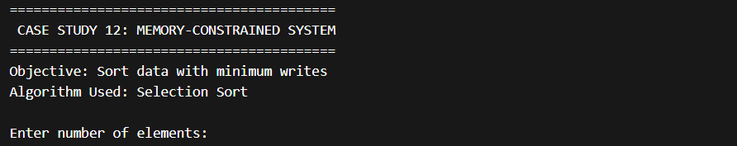

2: Entered Input
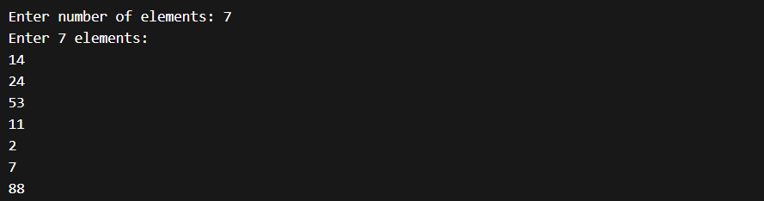

3: Original Dataset

4: Sorted Dataset

5: Performance Report
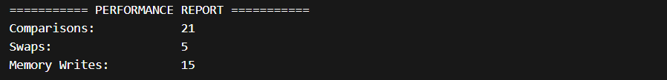

6: Outcome
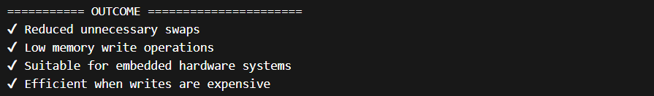

- Problem Statement / Case Study Results and Conclusion.

Results
- Dataset sorted successfully
- Reduced number of swaps
- Memory writes minimized
- Performance metrics displayed clearly
Limitations
- Time complexity is O(n²) (not efficient for large data)
- No dynamic memory optimization
- No file handling

Conclusion
This case study demonstrates how Selection Sort can be effectively used in memory-constrained embedded systems to minimize write operations. Although not the fastest algorithm, it is highly efficient in scenarios where memory writes are costly.
The project highlights the practical use of C++ and algorithm optimization techniques for hardware-efficient computing.

- References
- C++ Tutorials (W3Schools, GeeksforGeeks, YouTube)
- Data Structures & Algorithms notes
- Classroom materials
- Git Repository
Rima – https://github.com/rimam02/DSA-Mini-Project.git

